# Project Design Phase-II

**Data Flow Diagram & User Stories**

|  |  |
| --- | --- |
| **Team ID** | **PNT2022TMID32303** |
| Project Name | Estimate the crop yield using data analytics |
| Maximum Marks | 4 Marks |

## Data Flow Diagrams:

A Data Flow Diagram (DFD) is a traditional visual representation of the information flows within a system. A neat and clear DFD candepict the right amount of the system requirement graphically. It shows how data enters and leaves the system, what changes the information, and where data is stored.

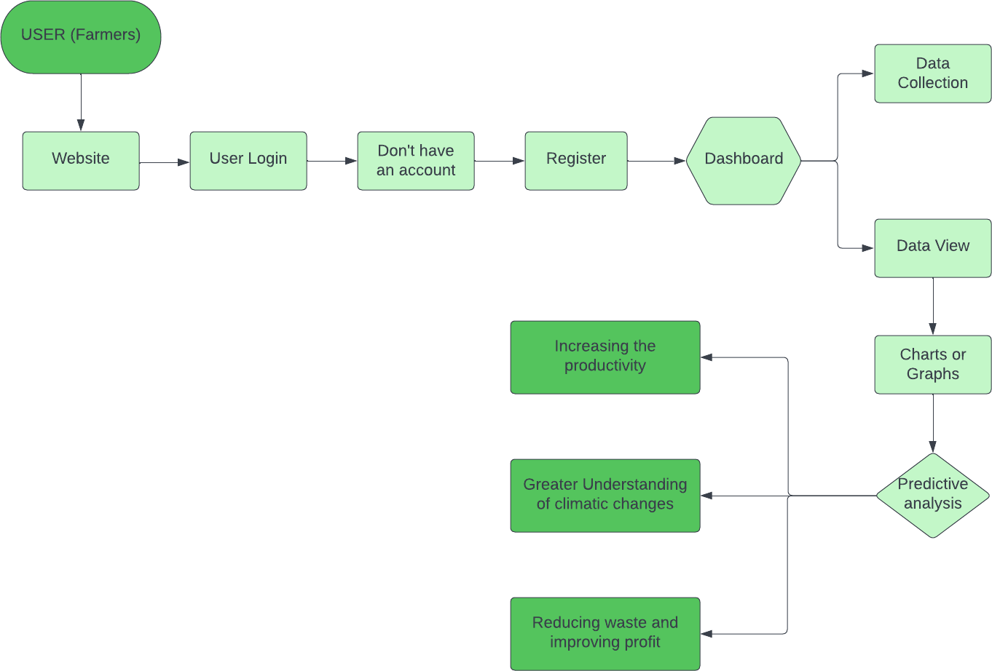

## User Stories

Use the below template to list all the user stories for the product.

|  |  |  |  |  |  |  |
| --- | --- | --- | --- | --- | --- | --- |
| **User Type** | **Functional Requirement**  **(Epic)** | **User Story**  **Number** | **User Story / Task** | **Acceptance criteria** | **Priority** | **Release** |
| Customer (Web user) | Registration | USN-1 | As a user, I can register for the website by entering my personal  details and creating account using  username and password. | I can access my account / dashboard | High | Sprint-1 |
|  |  | USN-2 | As a user, After completed the registration I will receive confirmation message through my registered emailid. | I can receive confirmation email | High | Sprint-1 |
|  |  | USN-3 | As a user, I can logged to my account  successfully. | I can register & access  the dashboard | Low | Sprint-2 |
|  | Login | USN-4 | As a user, I can logged in my account using my username and password. | I can access the  dashboard by login into the website. | High | Sprint-1 |
|  | Dashboard | USN-5 | As a User, I can view and access the information in the dashboard. | I can analyse the current activities of  crop production. | High | Sprint-1 |
|  |  | USN-6 | As a Web User, using the website | The website must |  |  |
|  | understanding the climatic changes | work properly and |
|  | properly and it helps in improving the crop | also there should beno |
|  | production. | error into the |
|  |  | information which is |
|  |  | provided. |
| Customer |  | CCE-1 | As customer care executive I will always | An executive will note | High | Sprint-2 |
| Care |  | be available for the interactionwith the | down the customers |  |  |
| Executive |  | customer to clarify the queries. | complaints and solve |  |  |
|  |  |  | their problems. |  |  |

|  |  |  |  |  |  |  |
| --- | --- | --- | --- | --- | --- | --- |
| **User Type** | **Functional Requirement**  **(Epic)** | **User Story**  **Number** | **User Story / Task** | **Acceptance criteria** | **Priority** | **Release** |
| Administrator |  | ADMIN-1 | As an Administrator, I will manage | Administrators can | High | Sprint-2 |
|  |  | backup and recovery, data modellingand | evaluate, design, |  |  |
|  |  | design, distributed computing, database | review and |  |  |
|  |  | systems, and a data security. | implementing a data |  |  |
|  |  |  | and they are also |  |  |
|  |  |  | responsible for |  |  |
|  |  |  | updating and |  |  |
|  |  |  | maintaining the data. |  |  |